

**ASSIGNMENT COVER SHEET**

**Student Name: Michael James & Martin Zubar**

**ID Number: B00019330**

**Course: BN302**

**Year: 1 OF 1**

**Lecturer:**

**Title of Assignment: Astronomy Learning Site Mobile App**

**Due Date: 6/12/14**

**Date Submitted:**

The material contained in this assignment is the author’s original work, except where work quoted is duly acknowledged in the text. No aspect of this assignment has been previously submitted for assessment in any other unit or course.

Signed: _______________________________ Date: ______/______/______

Contents

Abstract 2

Design 3

Git Hub set up 3

Facebook page for the site 4

Implemented features 5

Wire framing 7

How the Application works page by page 11

Required features 11

Do we have all the required features? 12

Who did what? 13

Screen shots 14

References 20

## Abstract

Given the recent success of the website we built for the customer the company has now decided they wish to have a mobile application also. The mobile site will have many of the features of the desktop version including the much lauded events page as well as a page to teach about some facts about the universe. It will be easy to navigate and have options on all pages to return to the home page. The emphasis is very much on simplistic design and making it very easy to navigate, this is the most important aspect of any mobile app, and we wish to avoid a clunky and clumsy interface.

## Design

As we discussed earlier. The design will be very minimal and functional. We have decided that the user must be able to switch between styles. For example if the user has poor eyesight he/she can switch to a style with more contrast to make things easier to see. We will keep each page clean and neat. We drew up some basic wire framing for each page. This will show the basic way we designed everything.

**Steps**

We needed to think about a number of things in changing over from Desktop to Mobile. Firstly the site online had a lot more stuff on it. We simply couldn’t put all of this on the mobile site or it would become clunky and un-usable. We decided that we would put only the more impressive features into the mobile site, along with the features the user’s seemed to like on the desktop version.

* Research some mobile apps
* Review the current desktop version of the site
* Make decisions on what needs to be in the mobile version
* Decided on our mobile versions layout and colour scheme
* We set up a git hub repository so we could both work on the project
* We began working on the project after the wire framing was done
* The main site layout was coded
* We set up the word press blog
* We linked our app to the word press blog
* Main content was added
* Site was optimised by putting in the required links and logos and so on
* We researched the API’s
* The API’s were coded and the pages we already had built previously were used for them
* We implemented 4 style types which the user can flick between

## Git Hub set up

We set up a Git Hub account each. I created a repository in my account and linked it to my local mobile application folder. From then on we worked by first syncing our local folders to Git Hub each time one of us has made changes, and then the next time the other person wanted to work, they synced their own local folder with the Git Hub one. This meant we could work effectively and very quickly by sharing the workload but eliminating the need to send files back and forth through email.

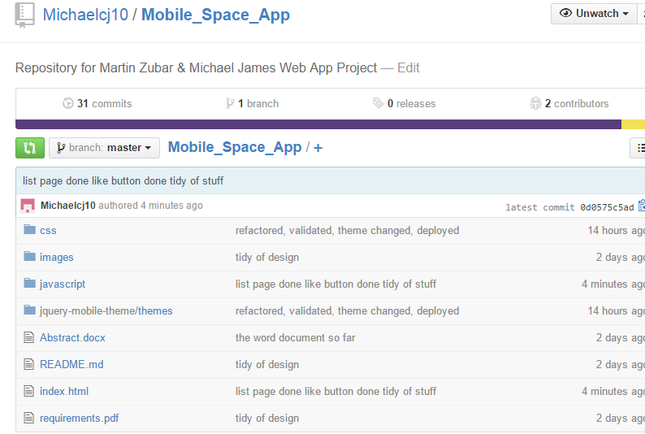

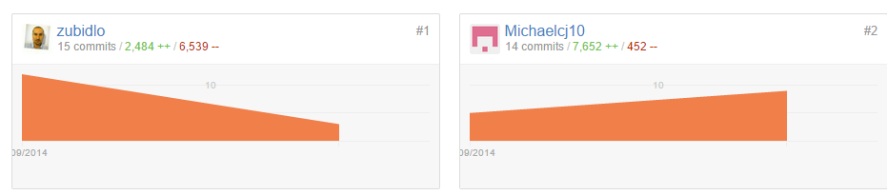

## Facebook page for the site

We set up a Facebook page for the site. We needed to implement a share and like button in the application so we needed to set up a page to show that the links worked. The creation of the page on Facebook was easy, and then we used a simple JavaScript method and HTML code to make the share and like buttons. On clicking the like button, it would automatically like the page we set up on Facebook.

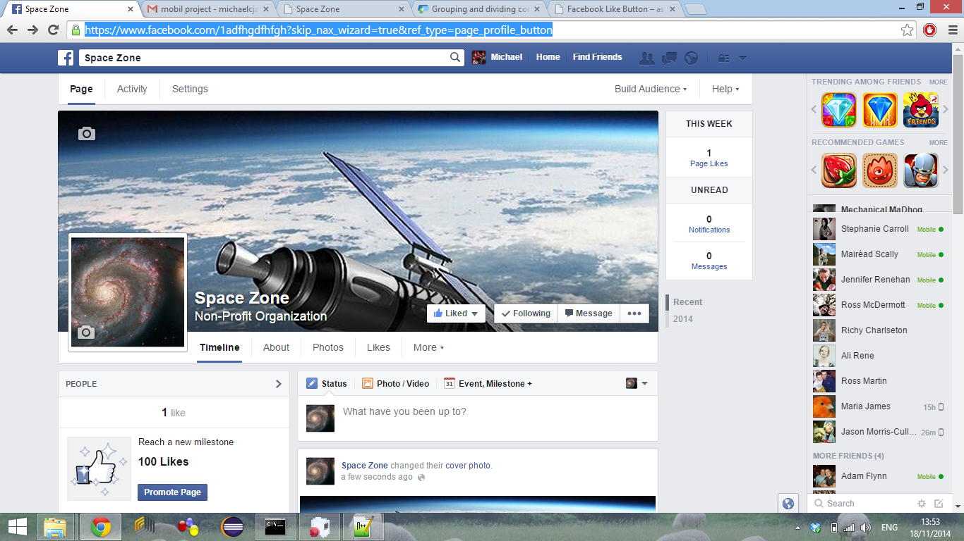

## Implemented features

**Feature**

We decided we would implement the events page feature.

**Why?**

This feature was one of our most popular on the desktop version. It is a very useful feature and could be implemented very easily without much bulky code.

**Feature**

We decided we would implement the map feature

**Why?**

We decided that having a map built into the mobile application makes sense. When the user is out and wishes to visit our branch it is very easy for them to do so without too much hassle of navigating to the desktop version.

**Feature**

We decided we would implement the facts page.

**Why?**

This feature was one of our most popular on the desktop version. It is a feature that was interesting to people and one that most people used when visiting the site. The facts could be updated regularly to give the user a dynamic and fulfilling experience when visiting the mobile site.

**Feature**

We decided we would implement Flickr Feature

**Why?**

We implemented the feature to allow the user get some images displayed to them from a Flickr account we have set up. This is important in the visual design of the site. Although we need to keep it minimal it does need some images to keep the users interested.

**Feature**

We decided we would implement the you tube API

**Why?**

We did this as in the desktop version we had a custom search bar linked to you tube. It would only display astronomy based results. For this API we have set it so the user can search through videos related to astronomy on their phone with ease. Again we feel this is an important feature to give the user a more dynamic experience and avoid the site being too basic and sparse.

**Feature**

We decided we would a planet facts page

**Why?**

From the page that displays facts, a button can be pressed to bring the user to this page. It displays information about the planets. We decided to implement this feature to give the user a more interesting experience and to add some content to the site, avoiding it being just about the API’s we have also implemented.

## Wire framing

**Home page**

This is the main page to which the user can navigate around the site from. There will be a logo and some extra tabs in the final model. The design is kept clean and near with no clutter.

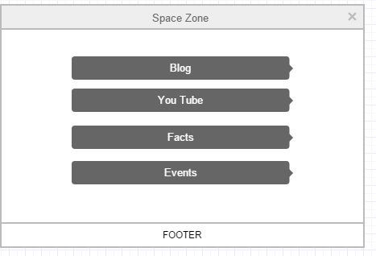

**Blog Page**

This page is the content for the word press blog we set up online. There are 3 articles and the user can view each one by simply clicking it. There are again links back to the home page.

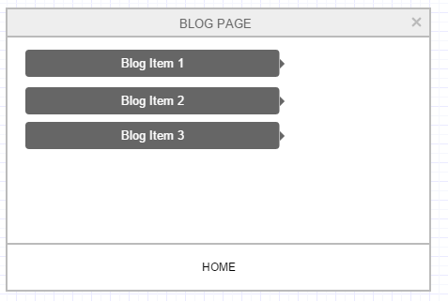

**Events Page**

On this page there are a list of upcoming events in the celestial calendar. The user can search through these events with the search bar and filter them to allow easy visibility. The user can then read about the event or click on it to open up a Wiki entry about that event.

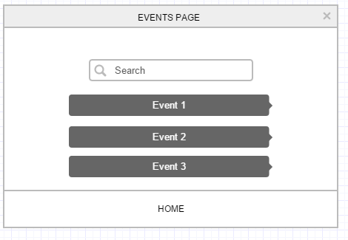

**You Tube API page**

On this page the user can search related videos using the you tube API that we learned about in a previous lecture. Again there are links to the home page from here. The final model of course will have more design features and be much more visually pleasing.

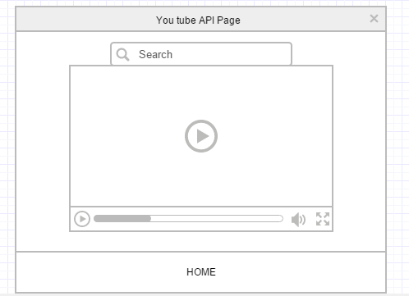

**Flickr Page**

On this page is the Flickr API. We can retrieve a number of images that we have uploaded to Flickr and allow the user navigate through them. The user can also click the image to show a bigger version.

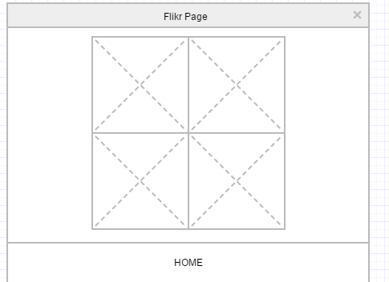

**Map Page**

On this page the user can use a Google Maps widget to check directions to our site from their current location.

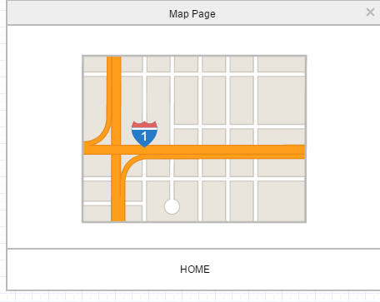

## How the Application works page by page

**Map Page**

On this page the user can use a Google Maps widget to check directions to our site from their current location.

**Events Page**

On this page is the Flickr API. We can retrieve a number of images that we have uploaded to Flickr and allow the user navigate through them. The user can also click the image to show a bigger version.

**You Tube API page**

On this page the user can search related videos using the you tube API that we learned about in a previous lecture. Again there are links to the home page from here. The final model of course will have more design features and be much more visually pleasing.

**Events Page**

On this page there are a list of upcoming events in the celestial calendar. The user can search through these events with the search bar and filter them to allow easy visibility. The user can then read about the event or click on it to open up a Wiki entry about that event.

**Blog Page**

This page is the content for the word press blog we set up online. There are 3 articles and the user can view each one by simply clicking it. There are again links back to the home page.

**Home page**

This is the main page to which the user can navigate around the site from. There will be a logo and some extra tabs in the final model. The design is kept clean and near with no clutter.

## Required features

* 2 API’s
* Info Box pop up
* Facebook share and Like
* Style switcher
* JSON feed for word press blog
* Navigation bar , buttons, headers, footer , button icons
* Modify some content to include lists
* Information dialog page
* 2 API’s
* An icon for the application
* Host the site
* Link to desktop version

## Do we have all the required features?

* 2 API’s ( Flickr and You tube page)
* Facebook share and Like ( Various pages )
* Style switcher ( All pages )
* JSON feed for word press blog ( Blog pages and word press site )
* Navigation bar , buttons, headers, footer , button icons ( Various pages )
* Modify some content to include lists ( Planet statistics page )
* Information dialog page ( Home page )
* An icon for the application ( Various pages )
* Host the site ( Done )
* Link to desktop version ( Done )

I believe we have all the features that we are required to have, laid out in the specification document. The two API’s allow the user look at videos and images related to the site’s topic. The info box shows up on clicking an icon in the home page corner and tells the user what the site is about. The Facebook share and like is on a couple of pages and lets the user share the page or like the Facebook page for the site. There is a style switcher on all pages that allows the user switch between 4 styles. The blog was done with word press and shows 3 current items the user can read through. They were read in with a JSON feed. There are JQuery widgets like navigation bars, tabs, and buttons and so on all pages. There is also a header and footer on each page. There are lists on a planet statistics page where the user can view some stats about certain planets, in list form. The application has an icon for the title bar which is a small telescope, there is also a site logo. The site is hosted online. There is a link to the desktop version on most pages also which brings you to the desktop version which we also have hosted on the same Web Server.

## Who did what?

Naturally in any shared project the work load will be allocated differently to each person. We both had different roles in the project trying to cater to each person’s strengths and bypass their weaknesses. The following is the work that each person did:

Martin

* Style switcher
* Web design
* Word press blog and blog page
* Screenshots to use in the document
* Hosting of the desktop and mobile version on a real life hosted web server
* The changeable style switcher
* Google maps

**Michael**

* Web design
* Git hub set up and hosting
* Documentation of the design and finished processes
* Home page design and set up
* Facts page and learning page
* Planet statistics page
* List page
* Facebook share and like
* Facebook page

**Both**

* You tube and Flickr API
* The document

## Screen shots

This is the home page. It has the logo, header and footer, the link to the info page and the style switcher.

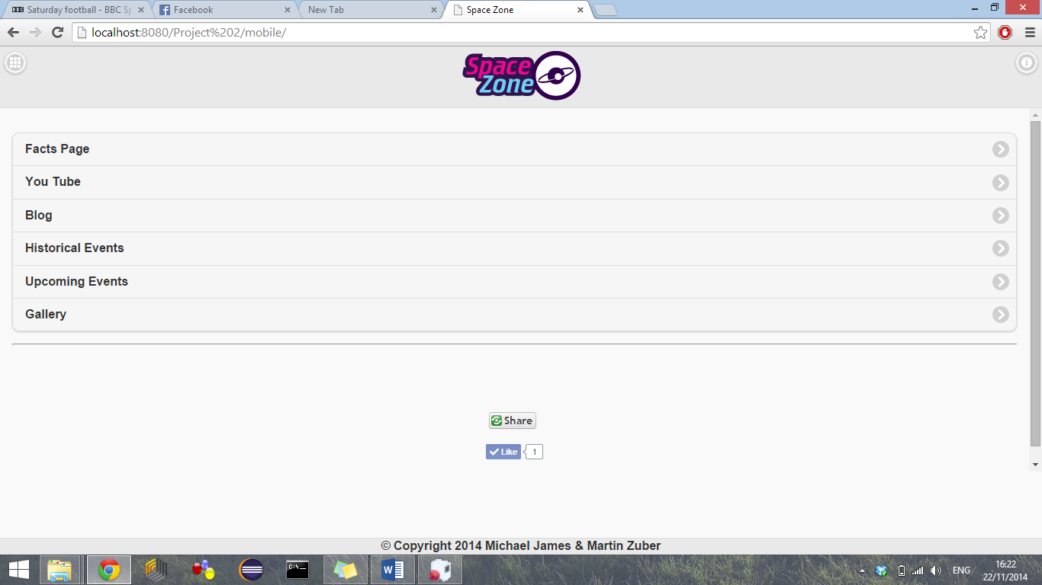

This is the Flickr page, you can see the 6 retrieved images, and on clicking them they show a larger image.

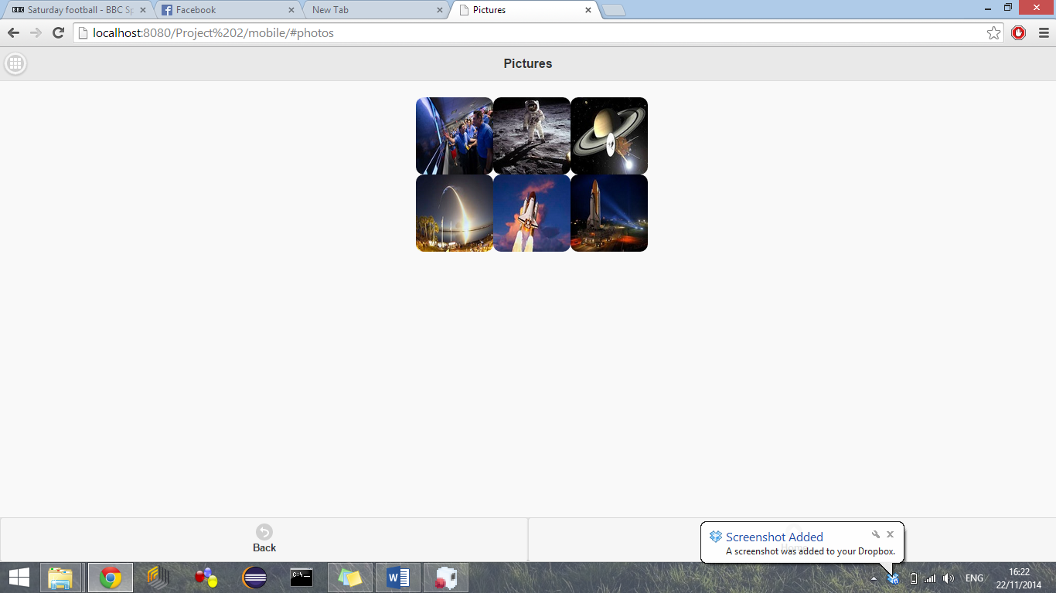

Here is the large image when clicked

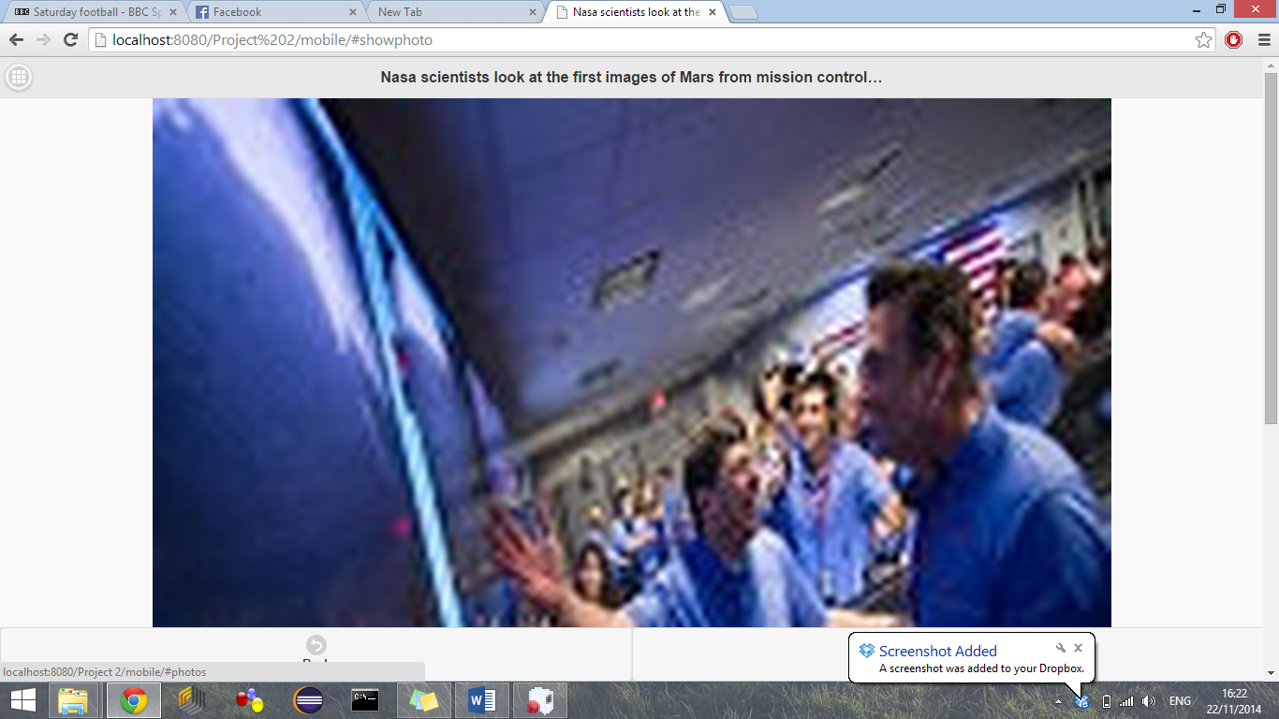

This page has some accordion style widgets. You can open them to view content, you can also search through them with a search bar.

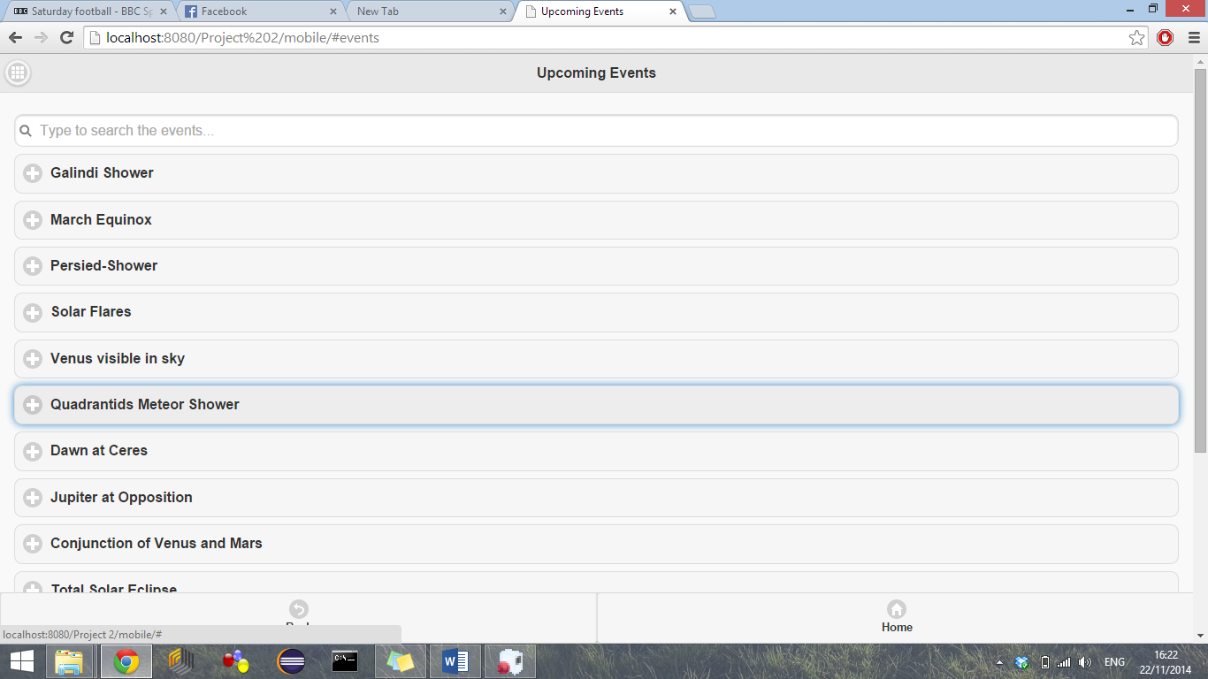

This page has the list as required in the specification document

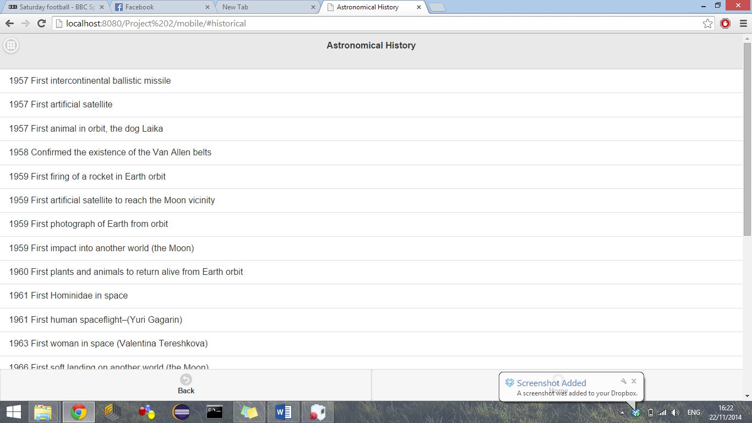

Here is our blog page with entries retrieved from the word press blog

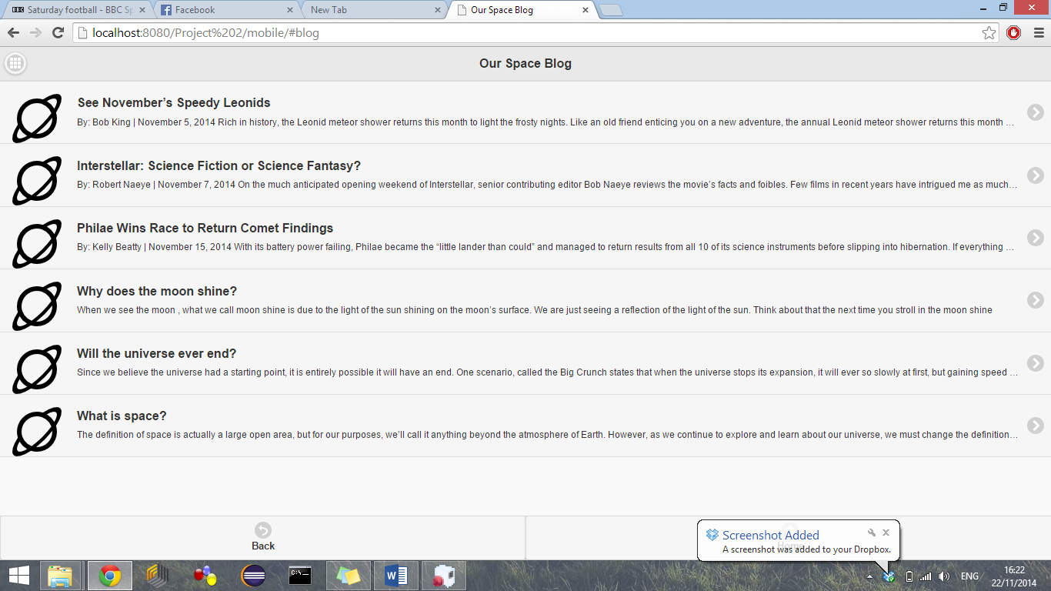

Here is A you tube API page with a max of 6 videos retrieved in a grid style layout. The videos naturally are related to the website topic.

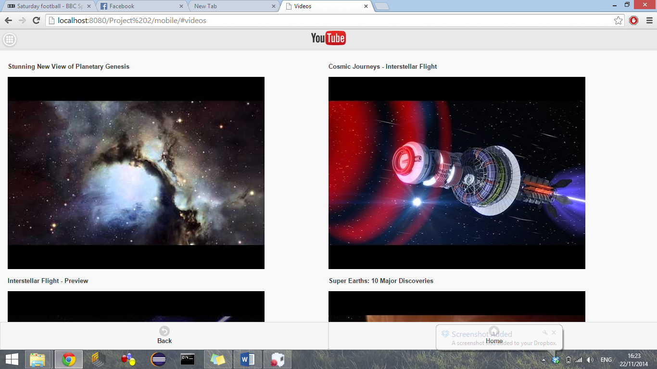

A page with some JQuery widgets including a link to another page with a list widget and some accordion stuff.

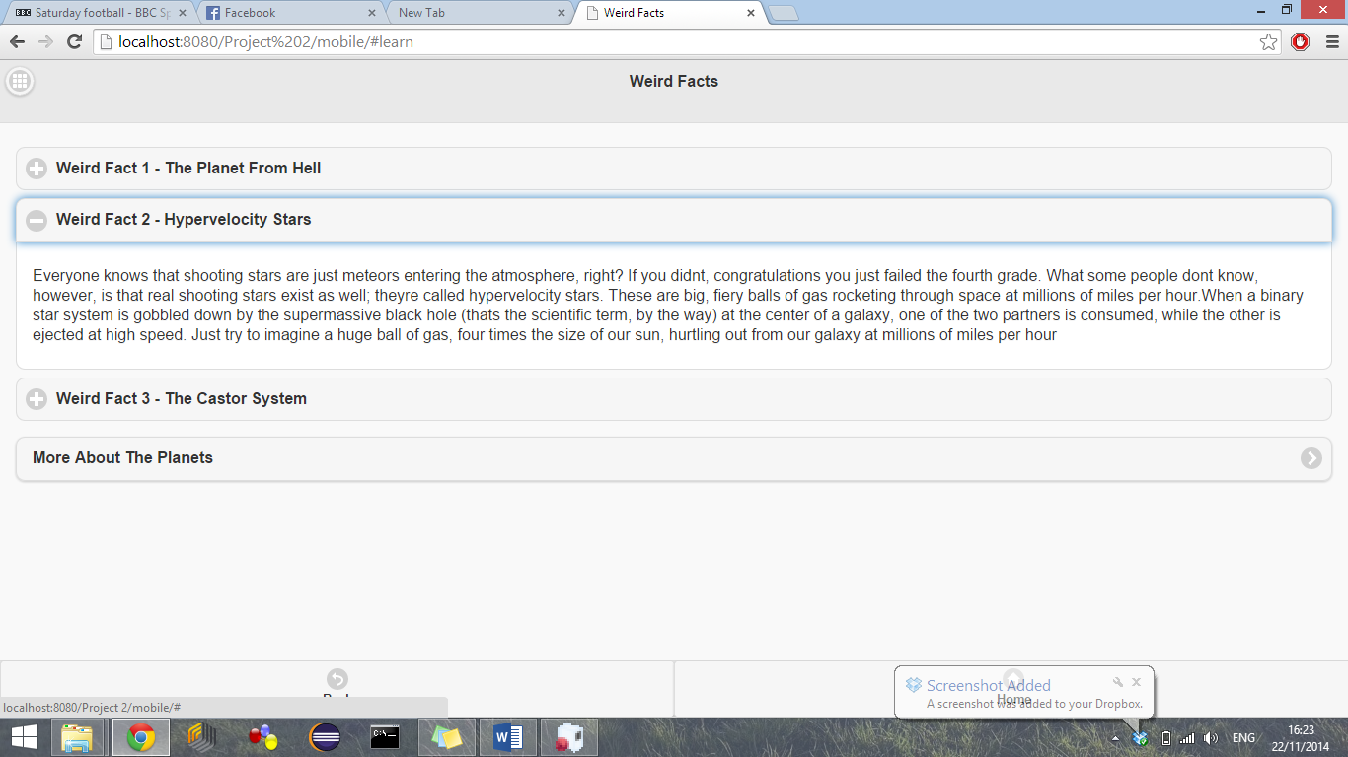

This is the information dialog box that can be opened from the link on the main page.

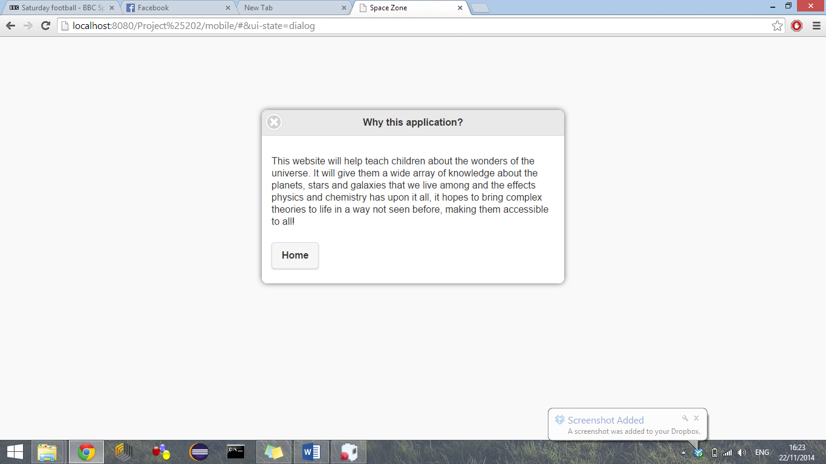

An example of the style switcher

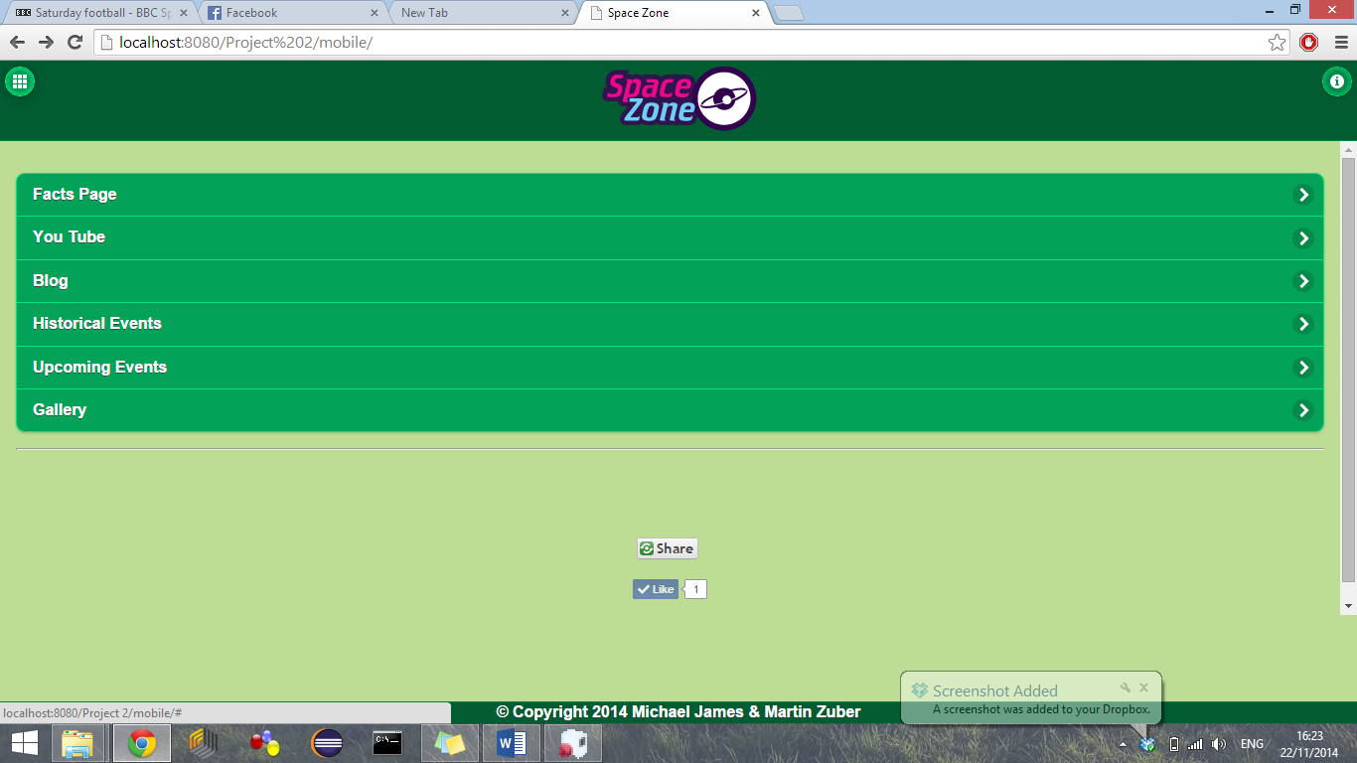

Google maps with directions screenshot

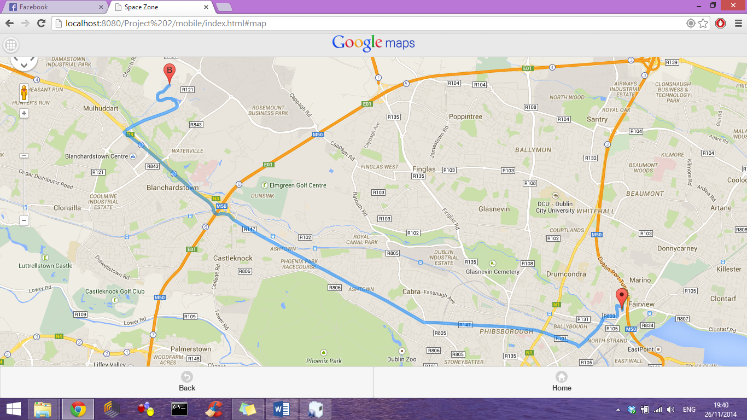

## References

<https://github.com/>

<https://developers.google.com/youtube/>

<https://www.flickr.com/services/api/>

<https://www.flickr.com/>

<http://demos.jquerymobile.com/1.4.5/icons/#Blackvs.whiteiconsets>

<http://www.w3schools.com/>

<http://moodle.itb.ie/>

<http://azure.microsoft.com/en-us/>

<http://validator.w3.org/>